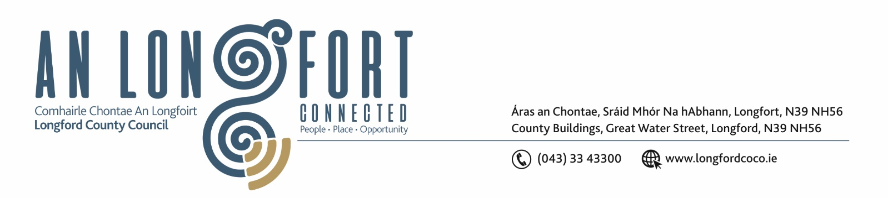

4u Eanair 2018.

Chuig: Gach Ball don Chomhairle.

A Chomhairleoir,

Iarrtar ort bheith i láthair ag Cruinniú Míosuil Chomhairle Chontae Longfoirt a tionólfar i Seomra na Comhairle, Aras an Chontae, Longford ar an Chéadaoin, 10u Eanair 2018 ag 4.00 p.m chun gnó a dhéanamh d’réir an Chláir thíos.

You are requested to attend the Monthly Meeting of Longford County Council to be held in the Council Chamber, Aras an Chontae, Great Water Street, Longford on Wednesday, 10th January 2018 at 4.00 p.m. to transact business, as set out on the Agenda hereunder.

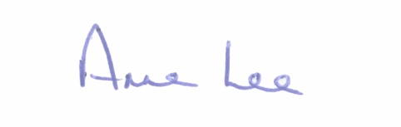
Mise le meas,

__________________
Anne Lee,
Meetings Administrator.

C L A R

- (i) Confirmation of Minutes of Special Committee Meeting of Longford County Council held on the 13th December 2017.

(ii) Confirmation of Minutes of Monthly Meeting of Longford County Council held on the
13th December 2017.

– copies enclosed.

- Matters arising from Minutes.

- To note Chief Executive Orders - enclosed.

4 . To note Monthly Management Report - to follow.

5. To note adopted Minutes of Corporate Policy Group Meeting held on
8th November 2017 - enclosed.

6. Finance & Information Systems.

(a) To note Public Liability Claims received during December 2017.

- Notice of Motion submitted by Councillor Michael Carrigy.

“I call on the Department of Children & Youth Affairs and the Department of Housing, Planning & Local Government to address the disparity in the requirement for private Early Years Services to pay commercial rates.”

7. Housing, Infrastructure, Environment & Emergency Services.

- (i) To note Adopted Minutes of Housing Services Strategic Policy Committee meeting
held on 5th September 2017 - enclosed.

(ii) To note Adopted Minutes of Infrastructural and Environmental Strategic Policy Committee meeting held on the 29th June 2017 – enclosed.

- Consideration of disposal of Property at No. 32, St. Mel’s Road, Longford
to Michael McGarry, Lisnabo, Newtownforbes, Co. Longford in accordance with the terms of
Section 183 of the Local Government Act 2001 issued on the 15th December 2017.

- Notice of Motion submitted by Councillor Mark Casey -

“In light of the recent bad weather conditions and the damage to the road network, that this Council writes to the Minister for Transport seeking emergency funding to repair the damaged roads.”

8. Economic and Community Development, Planning, Human Resources & Corporate Services, Cultural & Recreational Services.

- To note Planning Applications received since December meeting of the Council.

(b) (i) To note Adopted Minutes of Economic Development and Enterprise Strategic Policy Committee Meeting held on the 18th September 2017 - enclosed.
(ii) To note Adopted Minutes of Planning and Development and Cultural Strategic Policy Committee Meeting held on the 25th September 2017 - enclosed

(c) Presentation on Regional Spatial and Economic Strategy.

(d) Consideration of Progress Report on Irish Language Scheme (Official Languages Act, 2003) - report to follow.

(e) Nomination of one member to Backstage Theatre Clg. – to replace Padraig Loughrey.

(f) Notice of Motion submitted by Councillor Mark Casey -

“That this Council sends a delegation to Waterford County Council to investigate how the Waterford Greenway was marketed and how to draw down on funding, so we can market the Royal Canal Greenway in the same manner.”

9. General.

- Correspondence – enclosed.

- Letter dated 22nd November 2017 received from the Department of Public Expenditure
and Reform regarding Local Redress Fund.

- Letter dated 7th December 2017 received from the Department of Health regarding
Mental Health Issues in County Longford.

- Circular F.14/17 – Electoral Amendment (Dail Constituencies) Act 2017 – Revision of
Dail Constituencies.

10. Votes of sympathy.



